AFRL-PR-ED-TR-2003-0034 AFRL-PR-ED-TR-2003-0034 Teleportation Physics Study
Eric W. Davis https://sgp.fas.org/eprint/teleport.pdf 2003 AIR FORCE RESEARCH LABORATORY AIR FORCE MATERIEL COMMAND EDWARDS AIR FORCE BASE CA 93524-7048

We begin our look into this concept by examining the propagation of light through space. We know from quantum field theory that light propagating through space interacts with the vacuum quantum fields (a.k.a. vacuum quantum field fluctuations). The observable properties of light, including the speed of light, are determined by these interactions. Vacuum quantum interactions with light lead to an effect on the speed of light that is due to the absorption of photons (by the vacuum) to form virtual electronpositron pairs followed by the quick re-emission (from the vacuum) of the photon (see Figure 4). The virtual particle pairs are very short lived because of the large mismatch between the energy of a photon and the rest mass-energy of the particle pair. A key point is that this process makes a contribution to the observed vacuum permittivity ε0 (and permeability µ0) constant and, therefore, to the speed of light c [c = (ε0µ0)−1/2]. pg. 22

The concept of “engineering the vacuum” was first introduced to the physics community by Lee (1988). Lee stated: “The experimental method to alter the properties of the vacuum may be called vacuum engineering…If indeed we are able to alter the vacuum, then we may encounter some new phenomena, totally unexpected.” pg. 22

Scharnhorst (1990) and Latorre et al. (1995) have since proved that the suppression of light scattering by virtual particle pairs (a.k.a. coherent light-by-light scattering) in the vacuum causes an increase in the speed of light accompanied by a decrease in the vacuum refraction index. This very unique effect is accomplished in a Casimir Effect capacitor cavity (or waveguide) whereby the vacuum quantum field fluctuations (a.k.a. zero-point fluctuations or ZPF) inside have been modified (becoming anisotropic and non-translational invariant) to satisfy the electromagnetic boundary conditions imposed by the presence of the capacitor plates (or waveguide walls). The principal result of this modification is the removal of the electromagnetic zero-point energy (ZPE) due to the suppression of vacuum ZPE modes with wavelengths longer than the cavity/waveguide cutoff (λ0 = 2d, where d = plate separation; see Figure 5). This removal of free space vacuum ZPE modes suppresses the scattering of light by virtual particle pairs, thus producing the speed of light increase (and corresponding decrease in the vacuum refraction index). We know from standard optical physics and quantum electrodynamics (QED) that the optical phase and group velocities can exceed c under certain physical conditions, but dispersion always ensures that the signal velocity is ≤ c. But recent QED calculations (see, Scharnhorst, 1990 and Latorre et al., 1995) have proved that in the Casimir Effect system, the dispersive effects are much weaker still than those associated with the increase in c so that the phase, group and signal velocities will therefore all increase by the same amount. Note that, in general, no dispersion shows up in all of the modified vacuum effects examined by investigators pg. 24

c* > c0 (vacuum refraction index < 1) when the modified vacuum has a lower energy density pg. 27 (17 of text)

We are not able to do technical work at nuclear distances at this time; however, that could change as ultrahigh precision measurement technology continues to evolve. The threshold for the onset of significant changes in light speed occurs when a < 10−12 m. This result is generally true for the other modified vacua surveyed in (2.15) – (2.19), since accessible (everyday) values for electric and magnetic field strengths, thermal temperatures and radiation densities are not large enough to overcome the size of the electron mass to create a measurable effect. However, there is a class of ultrahigh intensity tabletop lasers that have achieved such extreme electric and magnetic field strengths and temperatures that it may now be possible to consider using them to explore vacuum modification effects in the lab. We will return to this theme in a later section. •Key Point: As disappointing as the Casimir Effect vacuum (and other modified vacua) results are, it should be strongly pointed out that special relativity theory says that if in one inertial reference frame an object travels only one part in 1016 (or even one part in 1032) times faster than c0, then one can find another reference frame where departure and arrival times of the object are simultaneous, and thus the velocity is infinite. This is what motivates us to look at a teleportation mechanism based on engineering of the vacuum. pg. 29

As recently elaborated by Puthoff (1999a, 2002a, b; Puthoff et al., 2002) the PV-GR approach, which was first introduced by Wilson (1921) and then developed by Dicke (1957, 1961), can be carried out in a self-consistent way so as to reproduce to appropriate order both the equations of general relativity and the match to the standard astrophysics weak-field experimental (PPN parameters and other) tests of those equations while posing testable modifications for strong-field conditions. It is in application that the PVGR approach demonstrates its intuitive appeal and provides additional insight into what is meant by a curved spacetime metric. Specifically, the PV-GR approach treats such measures as the speed of light, the length of rulers (atomic bond lengths), the frequency of clocks, particle masses, and so forth, in terms of a variable vacuum dielectric constant K in which the vacuum permittivity ε0 transforms as ε0 → Kε0 and the vacuum permeability transforms as µ0 → Kµ0 (see also, Rucker, 1977). In a planetary or solar gravitational potential K = exp(2GM/rc02) > 1 (M is a local mass distribution, r is the radial distance from the center of M) while K = 1 in “empty” or free asymptotic space (Puthoff, 1999a, 2002a, b; Puthoff et al., 2002). In the former case, the speed of light is reduced, light emitted from an atom is redshifted as compared with a remote static atom (where K = 1), clocks run slower, objects/rulers shrink, etc. See Table 1. pg. 31

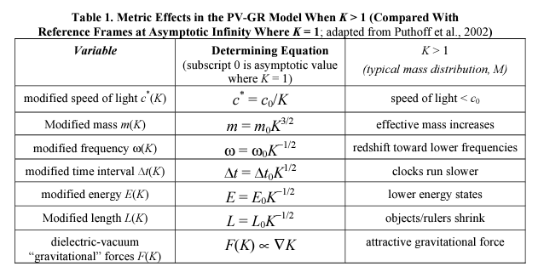
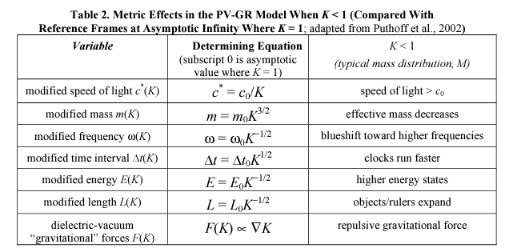

There are several ideas on how to generate negative energy in the lab that could potentially be extracted and concentrated in the proper fashion to induce the traversable flat-face wormhole outlined in Section 2.1.1 or induce the K < 1 condition (in the PV-GR model) outlined in Section 2.2.1. The schemes for generating negative energy are:

Casimir Effect (described in Section 2.2): This is the easiest and most well known way to generate negative energy in the lab. The energy density ρCasimir = −(π2ħc0/240)a−4 within a Casimir capacitor cavity is negative and manifests itself by producing a force of attraction between the capacitor plates. This has been measured in the lab (see above references). Forward (1998) proposes a mechanism for the endless extraction of energy from the vacuum in a Casimir cavity by cyclic manipulation of the cavity dimensions.

Moving Mirror : Negative quantum vacuum energy can be created by a single moving reflecting surface (a moving mirror). If a mirror moves with increasing acceleration, then a flux of negative energy emanates from its surface and flows out into the space ahead of the mirror (Birrell and Davies, 1982). However, this effect is known to be exceedingly small, and it is not the most effective way to generate negative energy. Optically Squeezed Laser Light : Negative quantum vacuum energy can also be generated by an array of ultrahigh intensity lasers with an ultrafast rotating mirror system. In this scheme a laser beam is passed through an optical cavity resonator made of lithium niobate crystal that is shaped like a cylinder with rounded silvered ends to reflect light. The resonator will act to produce a secondary lower frequency light beam in which the pattern of photons is rearranged into pairs. This is the quantum optical “squeezing” of light effect. (See Section A.2 in Appendix A for a complete definition and description of squeezed quantum states.) Therefore, the squeezed light beam emerging from the resonator will contain pulses of negative energy interspersed with pulses of positive energy. Another way to squeeze light would be to manufacture extremely reliable light pulses containing precisely one, two, three, etc. photons apiece and combine them together to create squeezed states to order. Superimposing many such states could theoretically produce bursts of intense negative energy. For the laser beam resonator example we find that both negative and positive energy pulses are of ≈ 10−15 second duration. We could arrange a set of rapidly rotating mirrors to separate the positive and negative energy pulses from each other. The light beam is to strike each mirror surface at a very shallow angle while the rotation ensures that the negative energy pulses are reflected at a slightly different angle from the positive energy pulses. A small spatial separation of the two different energy pulses will occur at some distance from the rotating mirror. Another system of mirrors will be needed to redirect the negative energy pulses to an isolated location and concentrate them there.

Gravitationally Squeezed Vacuum Energy : A natural source of negative quantum vacuum energy comes from the effect that gravitational fields (of astronomical bodies) in space have upon the surrounding vacuum. For example, the gravitational field of the Earth produces a zone of negative energy around it by dragging some of the virtual particle pairs (a.k.a. virtual photons or vacuum ZPF) downward. This concept was initially developed in the 1970s as a byproduct of studies on quantum field theory in curved space (Birrell and Davies, 1982).

FTL Communication : Experiments verifying that EPR entanglement obeys Special Relativity (Seife, 2000; Scarani et al., 2000; Gisin et al., 2000; Zbinden et al., 2000a, b) determined that quantum information via EPR photon pair entanglement must travel > 107 times light speed. pg. 59

